SESSION 7 ASSIGNMENT 1

COMPUTING THE MOVING AVERAGE

Given a sequence of n values x1, x2, ..., xn and a window size k>0, the k-th moving

average of the given sequence is defined as follows:

The moving average sequence has n-k+1 elements.

Write a function to find moving average in an array over a window:

Test it over [3, 5, 7, 2, 8, 10, 11, 65, 72, 81, 99, 100, 150] and window of 3.

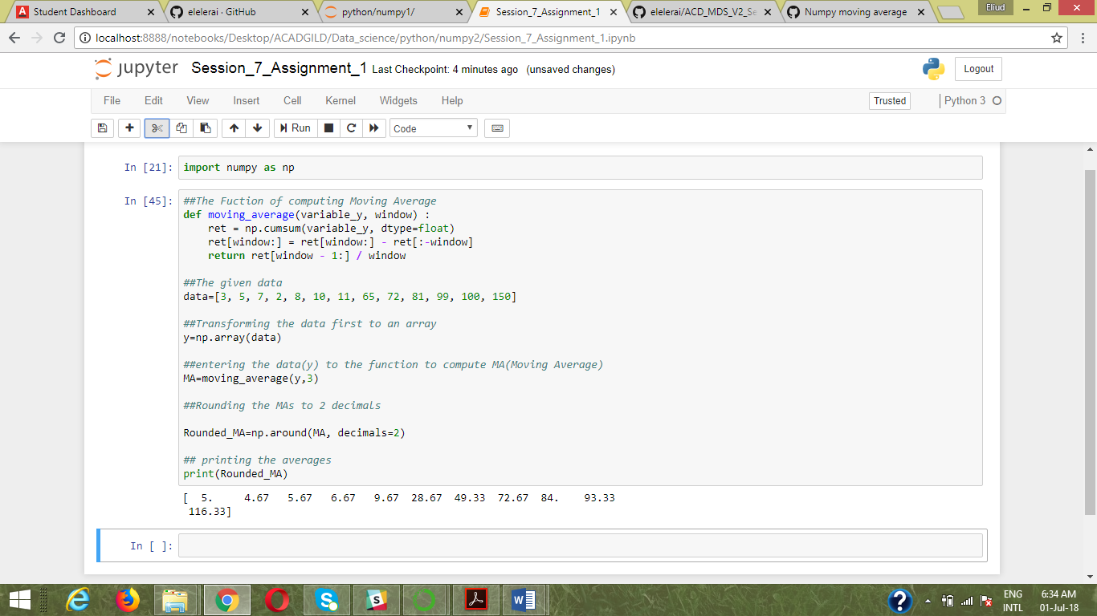

N=13,k=3,n-k+1=11

Hence the Prove